Getting Started Instructions

- Athletic Director Signs Up to Generate “User Profile”
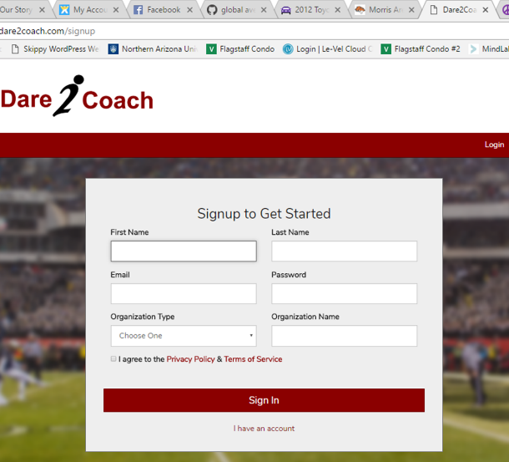
- Athletic Director Purchases License
- Begin to add teams.
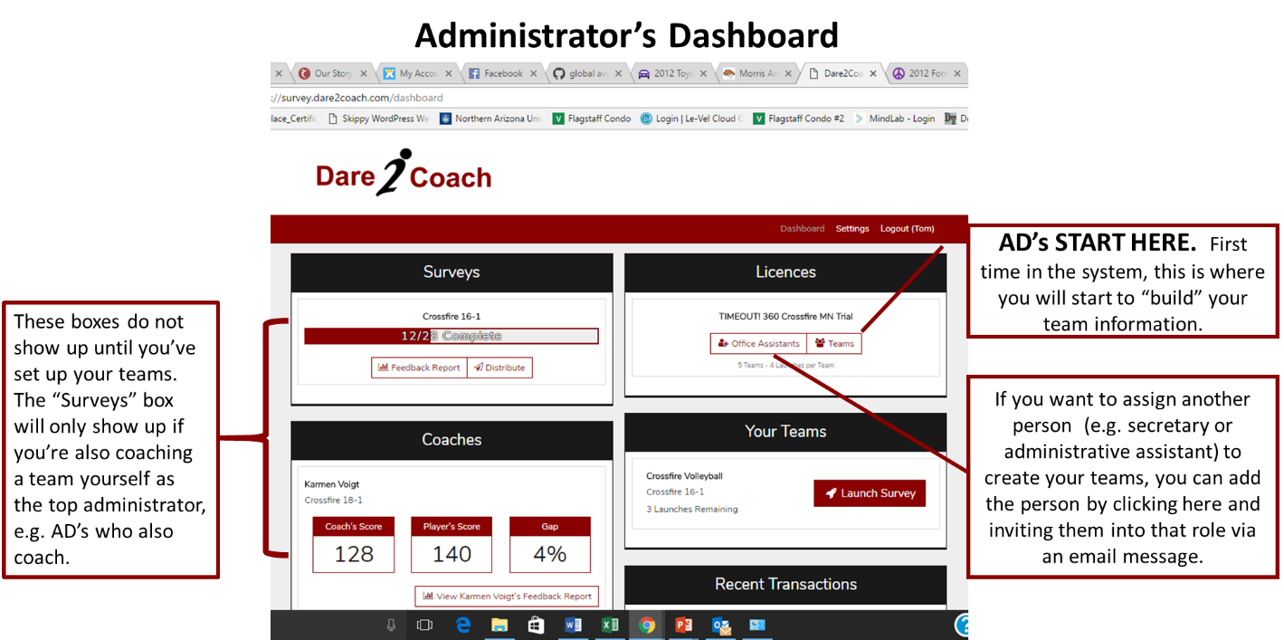

FYI…this is what the Team screen looks like when you’re populating the team information.
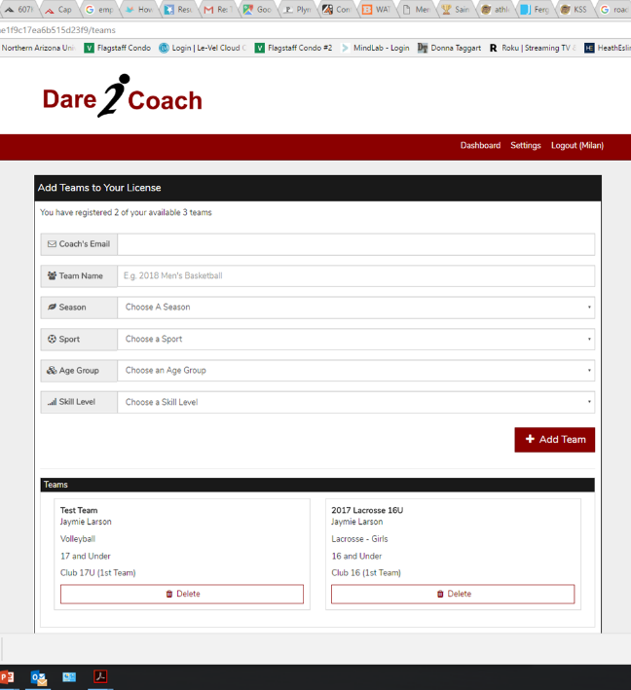
- Coach receives invitation from AD or “office assistant.” Coach now has a “Dashboard.” Looks like this…
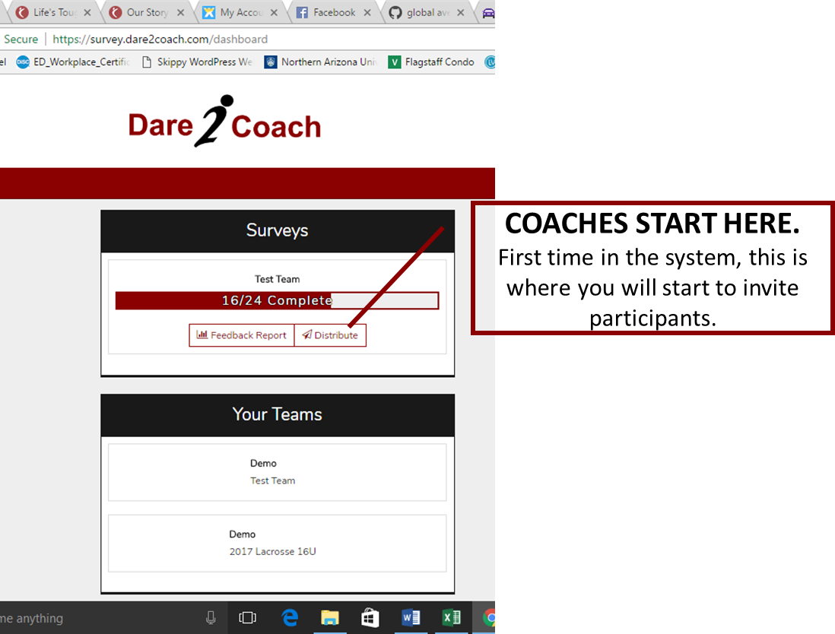
FYI, this is the screen COACHES will see when they start inviting participants:
